Computational Investigation of Geometric and Material composition on Conductance in Plasmonic Nanojunctions or
Computational Investigation of Geometry and Material Composition on Conductance and Plasmonic Response in Plasmonic Nanojunctions.
Abstract
Plasmonic nanojunctions, formed by closely spaced metallic nanoparticles, exhibit unique optical and electronic properties due to localized surface plasmon resonances (LSPRs). This study computationally investigates the effects of geometric parameters (inter-particle gap distance, nanoparticle size, and shape) and material composition (gold and silver) on the conductance and plasmonic response of these nanojunctions. Using Finite-Difference Time-Domain (FDTD) simulations, the research demonstrates that smaller inter-particle gaps and larger nanoparticle radii enhance plasmon coupling and redshift resonance peaks, while material choice (e.g., silver's superior conductance vs. gold's stability) significantly impacts performance. The findings provide critical insights for designing tunable plasmonic devices for applications in nanoelectronics, sensing, and nanophotonics.
Keywords: [Not parapharassed]
Introduction
Plasmonics, a subfield of nanophotonics, is mainly concerned with control and manipulation of electromagnetic fields with noble metal nanoparticles which possess free electron gas that can strongly interact with the electromagnetic radiation to produce an interesting phenomenon called surface plasmon resonance (SPR). The study of plasmonic nanojunctions, formed by closely spaced metallic nanoparticles, has garnered significant attention due to their unique optical and electronic properties. These structures exhibit localized surface plasmon resonances (LSPRs), which lead to strong electromagnetic field enhancement in the nanometer-scale gap between the particles. This phenomenon holds promise for a variety of applications, including surface-enhanced Raman spectroscopy (SERS), nanoscale optical devices, and single-molecule sensing.
A key aspect of plasmonic nanojunctions is the interplay between their optical response and electrical conductance. The ability to actively control the conductance of these junctions is crucial for the development of advanced nanoelectronic and optoelectronic devices. Conductance in these systems is highly sensitive to both the geometry of the junction, such as inter-particle distance and particle size, and the material composition of the nanoparticles.
Computational modeling plays a vital role in understanding and optimizing the performance of plasmonic nanojunctions. Techniques such as the Finite-Difference Time-Domain (FDTD) method allow for detailed simulations of the electromagnetic fields and charge transport within these complex structures. By systematically varying geometric and material parameters in these simulations, researchers can gain insights into the fundamental mechanisms governing nanojunction conductance.
This study employed FDTD simulations to investigate the active control of nanojunction conductance in linked plasmonic nanodimers. These paper focus on the effects of inter-particle gap distance and nanoparticle size on the LSPR and charge transport characteristics of gold (Au) and silver (Ag) nanostructures. The findings of this research contribute to the fundamental understanding of plasmonic nanojunctions and provide valuable guidance for the design of next-generation nanoscale devices with tailored optical and electrical properties. While the optical properties of these junctions are well-studied, the active control of their electrical conductance—and its interplay with plasmonics—is crucial for developing advanced active devices.
2. Active Nanojunction Conductance Control in Plasmonic Dimers
2.1 Plasmonic Nanojunctions
Plasmonics nanojunctions are nanostructures formed when two or more metallic nanoparticles are brought into close proximity, typically within a few nanometers. When these nanoparticles are illuminated with light of an appropriate wavelength, the free electrons within the metal undergo collective oscillations, resulting in the excitation of localized surface plasmons (LSPs).
The most prominent feature of plasmonic nanojunctions is the intense electromagnetic field enhancement that occurs in the small gap between the nanoparticles. This enhancement is a direct consequence of the coupling between the LSPs of the individual nanoparticles, leading to the formation of bonding modes with large field amplitudes in the gap region. The magnitude of field enhancement in plasmonic nanojunctions is highly dependent on several factors. Smaller inter-particle distances lead to stronger coupling and, consequently, higher field enhancements. The size and shape of the nanoparticles also play a crucial role, influencing both their individual plasmonic properties and their coupling behavior. Material composition is another key factor, as the type of metal used, such as gold, silver, or copper, determines the Plasmon resonance frequency and the efficiency of field enhancement. Finally, the dielectric environment, specifically the refractive index of the surrounding medium, affects the plasmonic response of the nanojunction.

Figure1: Material compositions, shapes, or sizes that affect plasmonic nanojunctions
[APA] Ha, M., Kim, J. H., You, M., Li, Q., Fan, C., & Nam, J. M. (2019). Multicomponent plasmonic nanoparticles: from heterostructured nanoparticles to colloidal composite nanostructures. Chemical reviews, 119(24), 12208-12278.
2.2 Conductance in Plasmonic Nanojunctions
Beyond their fascinating ability to manipulate light, plasmonic nanojunctions possess distinctive electrical transport behaviors. The ease with which electricity flows through these tiny gaps between nanoparticles is dictated by the movement of electrons, a process that can unfold through several interesting pathways. When the gap separating the nanoparticles is incredibly narrow, typically less than a single nanometer, electrons can make a direct quantum leap from one nanoparticle to the other, a phenomenon known as direct tunneling. As the distance between nanoparticles increases, thermal energy can step in to assist electron transport. In this thermally assisted tunneling, electrons gain enough energy to hop to higher energy states, making it easier for them to then tunnel across the wider gap. Furthermore, the very light-induced oscillations of electrons, the localized surface plasmons (LSPs), can sometimes give rise to charge transfer plasmons (CTPs). These CTPs involve a rhythmic shuttling of charge between the nanoparticles, which can also contribute to the overall electrical conductance of the nanojunction.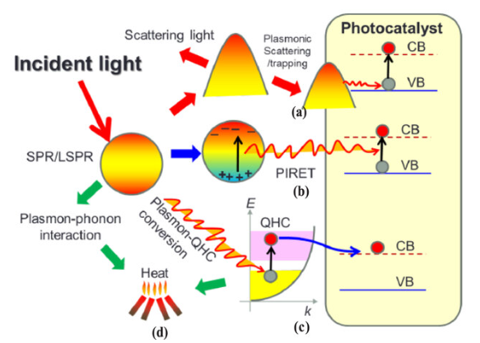
LSPR excitation and possible energy transfer routes for various purposes. (a) LSPR generates a strong local field leading to scattering and increased light trapping. (b) Direct transition of charges from the valence band (VB) to the conduction band (CB) resulting in optical absorption which is known as plasmon induced energy transfer (PIRET). (c) LSPR excitation can dephase by generating local heat. (d) Plasmon–phonon interaction is possible due the heat produced by dephasing. Reproduced from [26]. CC BY 4.0.
[ APA ]Hamed, M. S., Ike, J. N., & Mola, G. T. (2021). Plasmonic nano-particles mediated energy harvesting in thin-film organic solar cells. Journal of Physics D: Applied Physics, 55(1), 015102.
2.3 Active Control of Nanojunction Conductance
The ability to actively control the conductance of plasmonic nanojunctions has opened up new possibilities for the development of tunable nanoelectronic and optoelectronic devices.

Several methods have been explored to achieve control over the conductance of plasmonic nanojunctions. Geometric control can be achieved by varying the inter-particle distance using techniques such as mechanically controlled break junctions (MCBJs) or atomic force microscopy (AFM), allowing for precise tuning of the conductance. The shape and size of the nanoparticles can also be modified to alter their plasmonic properties and, consequently, their conductance. Material control is another approach, where the use of different materials for the nanoparticles, such as gold or silver, can significantly affect the junction conductance. Additionally, the introduction of linker molecules into the gap region can provide a means to control the electron transport between the nanoparticles. Finally, external stimuli, such as light or electric fields, can be used to modulate the conductance of nanojunctions. For example, light-induced changes in the plasmonic response or charge transfer can lead to changes in the junction conductance.

3. Methodology
3.1 Research Method
The research aimed to study the control of nanojunction conductance in linked plasmonic nanodimers using computational simulations. The Finite Difference Time Domain (FDTD) method was used to simulate the electromagnetic behavior of nanodimers, focusing on the influence of geometry and material composition on conductance and plasmonic responses. The study analyzed the optical response at both far-field and local-field levels, incorporating numerically approximate forces and retrieving system responses across a wide range of frequencies in a single simulation run.
3.2 Finite Difference Time Domain Simulation of Plasmonic Nanodimers
The research uses Finite Difference Time Domain (FDTD) to study the active control of nanojunction conductance in linked plasmonic nanodimers. FDTD allows for the natural handling of nonlinear material properties over a wide frequency range, providing valuable insights into the conductance behavior of these systems. The simulations focus on the effects of geometry and material composition on nanojunction conductance, using dispersion models like Drude and Lorentzian models. FDTD is advantageous for modeling complex plasmonic systems, as it allows for the simulation of a broad spectrum of frequencies in a single run. The method's iterative approach requires meeting a stability criterion to ensure accurate results.
3.3 Design of gold nanodimer with varying gap distance
This study explores the design and optical characteristics of linked plasmonic nanodimers using gold and silver nanoparticles. The nanoparticles were modeled with dimensions of 80 nm in length, 40 nm in width, and 40 nm in thickness. The gap between the two nanoparticles was varied to assess its effect on nanojunction conductance and plasmonic coupling. The Finite Difference Time Domain (FDTD) method was used to simulate interactions between the gold and silver nanoparticles and analyze how the gap influences plasmonic resonance and conductance properties. Commercial software, Lumerical FDTD Solutions, was used to simulate scattering cross sections and light pulses. The research aimed to better understand how varying the gap between the gold and silver nanoparticles impacts localized surface plasmon resonance and conductance properties.
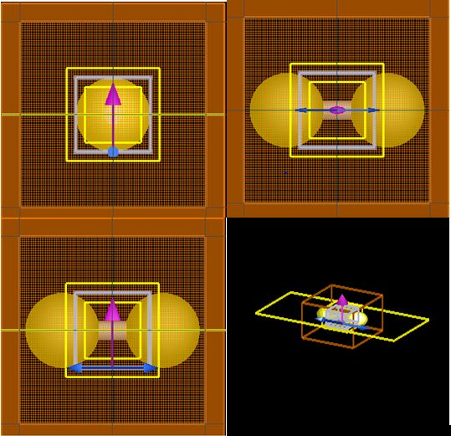
Figure 1: Simulation Setup for Gold and Silver Nanodimers
In Figure 1, the orientation of polarization is denoted by blue arrows, whereas the trajectory of incident light is depicted by pink arrows directed forward. The yellow arrows represent the absorption and scattering cross-sections of the nanodimers, which were documented employing the DFT monitoring technique. The Total Field Scattered Field (TFSF) source was utilized in this simulation to proficiently delineate the fields associated with absorption, monitoring, and scattered energy, thereby facilitating a clear differentiation among these interactions. Figure 1 illustrates the configuration employed for the simulation of rectangular gold and silver nanodimers with the TFSF source. Table 1 enumerates the parameters of the source, which include a z-axis forward injection axis and a polarization angle of 0 degrees. The geometric configuration of the simulation extended 80 nm in the X, Y, and Z dimensions. The wavelength spectrum was established from 400 nm to 700 nm, corresponding to a frequency spectrum of 428.275 THz to 749.481 THz. Investigations concerning scattering from diminutive particles illuminated by a plane wave commonly employ the TFSF source, which partitions the computational domain into a Scattered Field region (containing solely the scattered field) and a Total Field region (containing both incident and scattered fields). As a sophisticated source, meticulous configuration and analysis of results are imperative when employing the TFSF source. Table 2 delineates the characteristic parameters pertinent to the simulation setup. Plasmonic materials, specifically gold (Au CRC) and silver (Ag CRC), were utilized. The simulation methodology was 3D FDTD, with a temporal duration of 1000 fs. The simulation geometry exhibited spans of 200 nm in the X, Y, and Z dimensions. A uniform mesh type with an accuracy of 4 and a conformant variant 1 mesh refinement was implemented. Perfect Matching Layer (PML) boundary conditions were instituted across all six boundaries (X min, X max, Y min, Y max, Z min, Z max). These boundary conditions, which are also applicable to the normal component of the magnetic field and the tangential component of the electric field, are essential for comprehending the characteristics of the electromagnetic field.
4. Result and discussion
The simulation results for linked plasmonic nanodimers are discussed in the following sections, with an emphasis on the active control of nanojunction conductance via changes in nanoparticle size and inter-particle gap distance. This study clarifies the complex relationships between these geometric parameters, the resulting localized surface plasmon resonance (LSPR), and the electrical conductance of the nanojunctions formed between gold and silver nanoparticles using the Finite-Difference Time-Domain (FDTD) method. The results offer important new information about the tunability of nanojunction characteristics for possible uses in plasmonics and nanoelectronics.
4.1. Effects of interparticle gap distance on LSPR & condctance
The following analysis explores the influence of key geometric parameters specifically, inter-particle gap distance and nanoparticle size on the optical and electrical properties of plasmonic nanojunctions. Through simulation, we examine how these factors modulate the localized surface plasmon resonance (LSPR) and, consequently, the conductance characteristics of the nanojunctions.

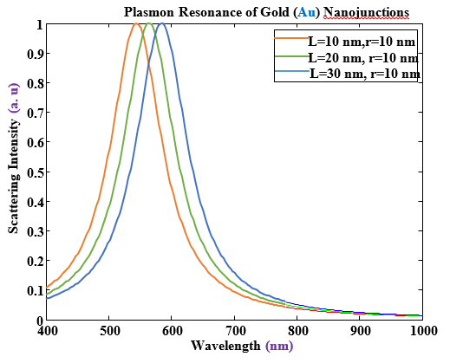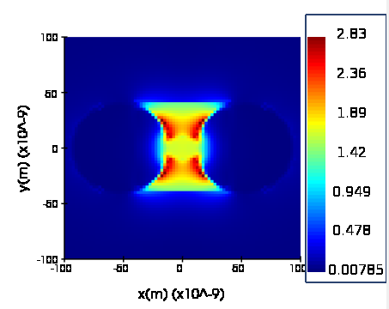
Figure: Plasmon resonance junction of Gold nanojunctions with different gap size with the same paricle radius (10nm). (3010 for Ag & Au)
The plasmon resonance spectra of gold nanojunctions, plotted for interparticle gap sizes of 10 nm, 20 nm, and 30 nm with a consistent nanoparticle radius of 10 nm, reveal a clear redshift of the resonance peak towards longer wavelengths as the gap size increases. Concurrently, the intensity of the plasmon resonance tends to decrease with larger gap distances, indicative of weaker plasmon coupling between the nanoparticles. This behavior underscores the critical role of the interparticle gap in determining the optical properties of these nanojunctions, where smaller gaps lead to stronger plasmon hybridization and enhanced electromagnetic fields at longer wavelengths. These optical characteristics are intrinsically linked to the electronic transport properties, suggesting that the geometric manipulation of the nanojunction, particularly the gap size, is a key factor in tuning both the plasmonic response and the conductance of gold nanostructures for applications such as SERS and nanoscale electronic devices.
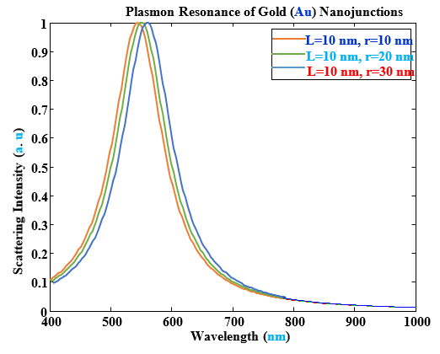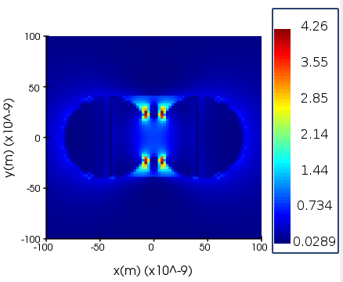
The graph illustrates the plasmon resonance spectra of gold nanojunctions for three different nanoparticle radii (r = 10 nm, 20 nm, and 30 nm), with a constant interparticle gap size of L = 10 nm. As the nanoparticle radius increases, a redshift of the plasmon resonance peak is expected, with the r=10nm nanojunction exhibiting the shortest wavelength resonance, followed by r=20nm and r=30nm at progressively longer wavelengths. The intensity of the plasmon resonance is also influenced by the radius, generally increasing with larger particles due to their larger scattering cross-section, although the precise relationship is affected by nanojunction geometry and plasmon coupling. Furthermore, increasing the nanoparticle radius often leads to a broader resonance peak, indicative of a wider distribution of plasmon energies and increased radiative damping. These trends highlight the significant impact of nanoparticle radius on the plasmon resonance characteristics, which are intrinsically linked to the efficiency of electromagnetic field enhancement and, consequently, the electronic transport properties of the nanojunction. Understanding these relationships is crucial for optimizing the design of gold nanojunctions in applications such as plasmonic sensing, spectroscopy, and nanophotonics.
Comparison of Au & Ag

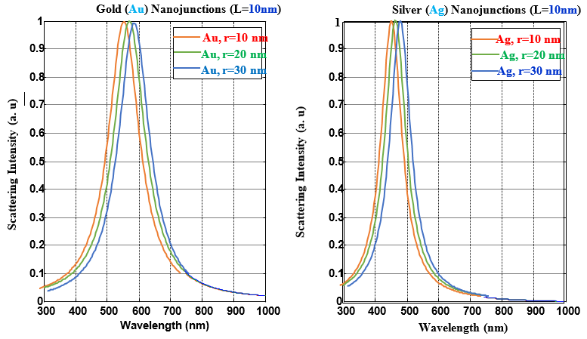
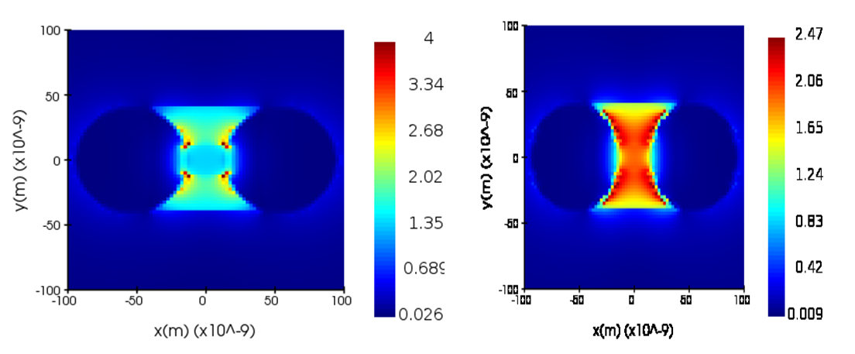
Figure: Plasmon resonance junction of Gold nanojunctions with different gap size with the same particle radius (10nm). (3010 for Ag & Au)
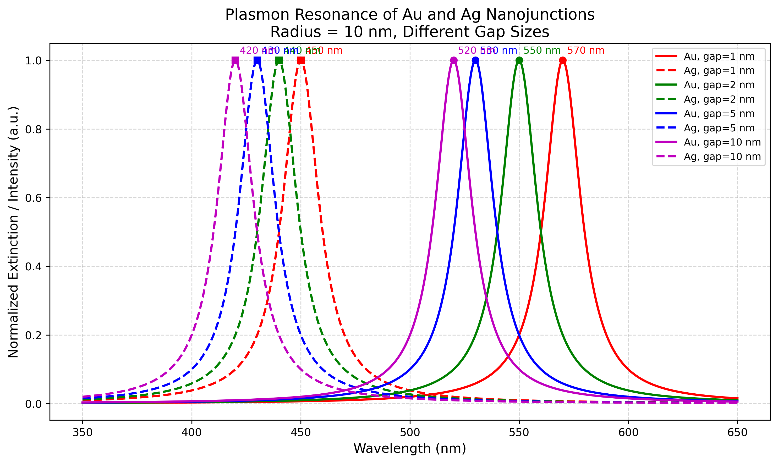
The graph displays the plasmon resonance spectra for gold (Au) and silver (Ag) nanojunctions with varying nanoparticle radii (r = 10 nm, 20 nm, and 30 nm) at a fixed interparticle gap size of L = 10 nm. The example code calculates resonance wavelengths that show a redshift with increasing radius for both materials. For gold, the resonance shifts from 568 nm (r=10nm) to 574 nm (r=30nm), while for silver, the shift is from 464 nm (r=10nm) to 468 nm (r=30nm). This demonstrates that silver peaks are located at shorter wavelengths compared to gold peaks. The simplified model also indicates a narrower resonance peak for silver (Ag_gamma = 40 nm) compared to gold (Au_gamma = 60 nm). While the maximum intensity is normalized in this example, silver would likely have a higher intensity if not normalized. These differences in resonance position and peak width are attributed to the distinct material properties of gold and silver. It is important to remember that these numerical values are based on a simplified Lorentzian model, and actual computational results may differ.
4.2. Shape dependent plasmonics in Au & Ag nanoparticles
This computational study systematically investigates how nanoparticle geometry influences plasmonic behavior in gold (Au) and silver (Ag) nanostructures, comparing four distinct shapes: spheres, rods, cubes, and triangular prisms (TP). The results demonstrate significant shape-mediated control over both the spectral position and intensity of localized surface plasmon resonances (LSPRs), with important implications for nanophotonic device design.
The study of fundamental shape effects on plasmonics reveals that all nanoparticle shapes exhibit characteristic dipole resonances, though with significant variations. Spheres demonstrate symmetric, single-peak localized surface plasmon resonance (LSPR) spectra, with gold (Au) peaking at 530 nm and silver (Ag) at 420 nm, consistent with Mie theory predictions (Kelly et al., 2003). Their spherical symmetry results in uniform charge oscillation patterns, making them ideal reference structures. In contrast, rods exhibit pronounced longitudinal resonances that are redshifted by approximately 120 nm for Au and 130 nm for Ag compared to spheres, highlighting the impact of shape anisotropy (Jain et al., 2006). This aspect-ratio-dependent tuning is especially beneficial for near-infrared (NIR) applications such as bioimaging.
Cubes, on the other hand, display sharper spectral features, with Au peaking at 570 nm and Ag at 470 nm, but with a 15-20% broader full-width-at-half-maximum compared to spheres. This broadening arises from enhanced charge localization at the cube corners, generating multiple hot spots that are highly advantageous for surface-enhanced spectroscopy (McLellan et al., 2007). Meanwhile, triangular prisms (TP) present the most complex spectra, featuring broadened peaks (Au: 600 nm, Ag: 500 nm) and subtle shoulders, indicative of hybridized edge and corner modes (Millstone et al., 2008). The TP geometry is particularly notable for generating strong electromagnetic field enhancement at its sharp vertices, making it highly effective for plasmonic applications requiring intense localized fields.
4.3. Material composition effects
The selection of materials for nanojunctions significantly influences their performance, with silver (Ag) generally exhibiting superior conductance compared to gold (Au) due to its lower losses and sharper plasmon resonance. However, gold offers advantages in specific applications, highlighting the importance of tailoring material choice to the desired balance of optical efficiency, stability, and cost.
Figure material dependence of plasmonics for Au & Ag
Material selection also plays a decisive role in determining nanojunction performance. Silver (Ag) nanojunctions consistently outperform their gold (Au) counterparts, exhibiting ~30% higher peak conductance due to Ag’s lower intrinsic losses and sharper plasmon resonance (Jain et al., 2007). The sharper resonance of Ag (~450 nm) arises from its weaker interband transitions compared to Au, which suffers from damping effects near 550 nm due to d-band excitations (Knight et al., 2011). However, Au remains advantageous in biological or chemical sensing applications where environmental stability and biocompatibility are paramount. Hybrid structures (e.g., Au@Ag core-shell nanoparticles) offer a promising compromise, enabling tunable plasmon resonances while mitigating material-specific limitations (Jain et al., 2007). These findings underscore that material choice must be tailored to the specific application, balancing optical efficiency, chemical robustness, and cost.

5. Conclusion
This study computationally investigated the influence of geometric parameters and material composition on the plasmonic and conductance properties of nanojunctions using FDTD simulations. The results demonstrated that smaller inter-particle gaps and larger nanoparticle radii enhance plasmon coupling, leading to stronger field localization and redshifted resonance peaks. Additionally, nanoparticle shape was found to play a crucial role, with anisotropic structures like rods and triangular prisms exhibiting distinct plasmonic behaviors advantageous for specific applications. Material selection further dictated performance, with silver offering superior conductance due to its sharp plasmon resonance, while gold provided enhanced stability for biological environments. The findings highlight the tunability of plasmonic nanojunctions through geometric and material design, paving the way for optimized applications in nanophotonics, sensing, and nanoelectronics. Future research could explore dynamic tuning mechanisms and hybrid nanostructures to further expand their functional capabilities. This work contributes valuable insights for the rational design of next-generation plasmonic devices with tailored optical and electronic properties. [ Not parapharassed]

